**Name:Sarfraz Hameed**

**Roll No: FA24-BCS-139**

**Section:A**

**Submitted to: Dr.Shahid Bhatti**

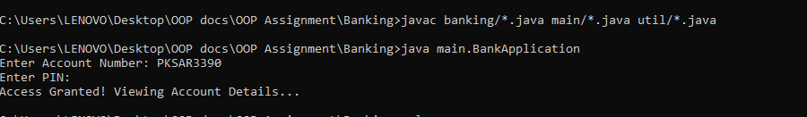

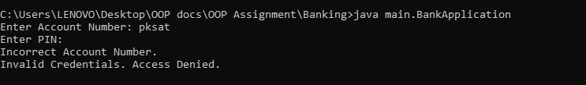

**Link to the repository:**